
Multiple layer protection for encryption using OPENSTEGO and hardening plus with WinRAR / WinZIP

Group 7
Names : Hilwa Annisa
: Rizky Nur Aziz

Class : 3CS1
Ivan Firdaus, S.T.
Tri Agus Riyadi, S.Kom., M.Kom

Faculty :

CEP-CCIT
FAKULTAS TEKNIK UNIVERSITAS INDONESIA
2025
1. Ivan Firdaus, S.T.
2. Tri Agus Riyadi, S.Kom., M.Kom

Project Title : Multiple layer protection for encryption using OPENSTEGO and hardening plus with winrar / winzipDiary
Batch Code : 3CS1
Start Date : October 05, 2025
End Date : October 17, 2025
Name of Faculty :

Names of Developer:
- Hilwa Annisa
- Rizky Nur Aziz
Date of Submission: October 20, 2025

PROJECT INFORMATION
Multiple layer protection for encryption using OPENSTEGO and hardening plus with winrar / winzip
We would like to express our deepest gratitude to God Almighty for His blessings and guidance, which have enabled us to complete this project titled “Multiple Layer Protection for Encryption Using OpenStego and Hardening Plus with WinRAR/WinZip.”
Our sincere appreciation goes to Mr. Ivan Firdaus, S.T., and Mr. Tri Agus Riyadi, S.Kom., M.Kom., for their valuable guidance and support throughout this project. We also thank our team members, Rizky Nur Aziz and Hilwa Annisa, for their dedication and cooperation in completing this work.
This project aims to implement a multi layer data protection system by combining OpenStego for steganography based security with additional encryption using WinRAR or WinZip. We realize that this report is not perfect, therefore, we welcome constructive feedback and suggestions. We hope this work can provide useful insights into the importance of digital data security.

Depok, 5thOct 2025

Authors

ACKNOWLEDGEMENT

System summary :
This system applies a multiple-layer protection method to secure digital data. The first layer uses OpenStego for steganography, hiding confidential files inside media files, while the second layer uses WinRAR/WinZip encryption as additional hardening with a password. The purpose of this system is to provide double security for sensitive data and prevent unauthorized access. The combination of steganography and encryption offers a simple yet effective approach to digital data protection through layered security.
In addition, this project also implements the CIA Triad principles to ensure comprehensive cybersecurity. The Confidentiality aspect is achieved by combining OpenStego and WinRAR, ensuring that data remains hidden and encrypted from unauthorized users. Integrity is maintained through encryption algorithms and password protection that prevent data modification without proper authorization, guaranteeing that the message remains unchanged. Meanwhile, Availability is supported by allowing authorized users to access the hidden file anytime using OpenStego and WinRAR, ensuring data remains accessible when needed.
Overall, the combination of OpenStego and WinRAR successfully implements the CIA Triad maintaining the confidentiality, integrity, and availability of digital data through a secure multilayer protection system.

SYSTEM ANALYSIS

In the digital era, data security has become a crucial aspect of information management. The increasing number of cyber threats, such as data theft, unauthorized access, and digital espionage, highlights the need for reliable protection methods. Conventional encryption alone is sometimes not enough to ensure data confidentiality, especially when files are transmitted or stored in shared environments.
To address this issue, a multiple layer protection system is proposed by combining OpenStego for steganography and WinRAR/WinZip for encryption hardening. OpenStego hides sensitive information inside media files, making it invisible to unauthorized users, while WinRAR/WinZip provides additional password based encryption. This combination creates a stronger and more secure protection layer for digital files.
Through this project, the implementation of double layer protection aims to demonstrate how steganography and encryption can work together to improve the confidentiality and integrity of digital data effectively.

BACKGROUND

Sytem Flow

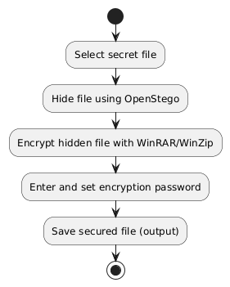

OPENSTEGO INSTALLATION

Download OpenStego at https://www.openstego.com/
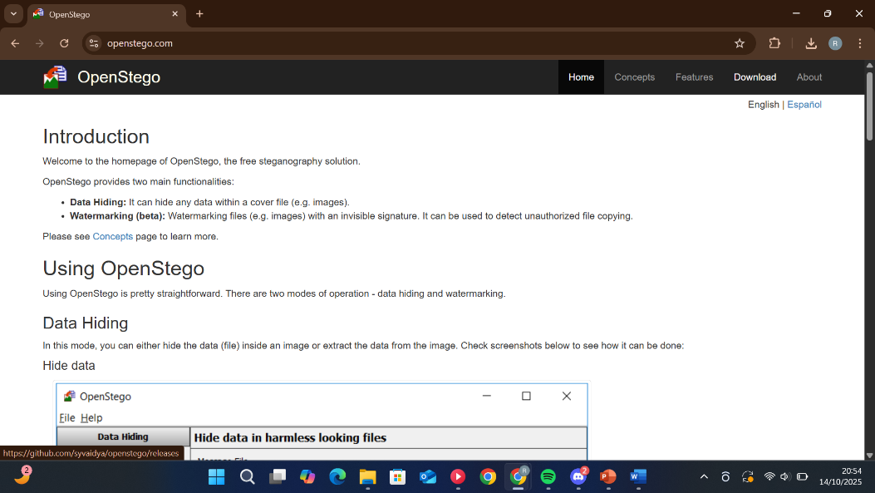

Accept the aggriment, click next,click install and wait until the installation finish
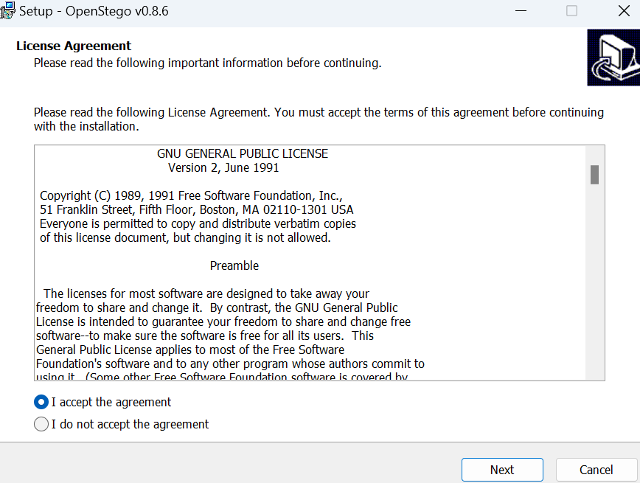

HIDE FILE USING OPENSTEGO

Open the OpenStego software and it will show like this
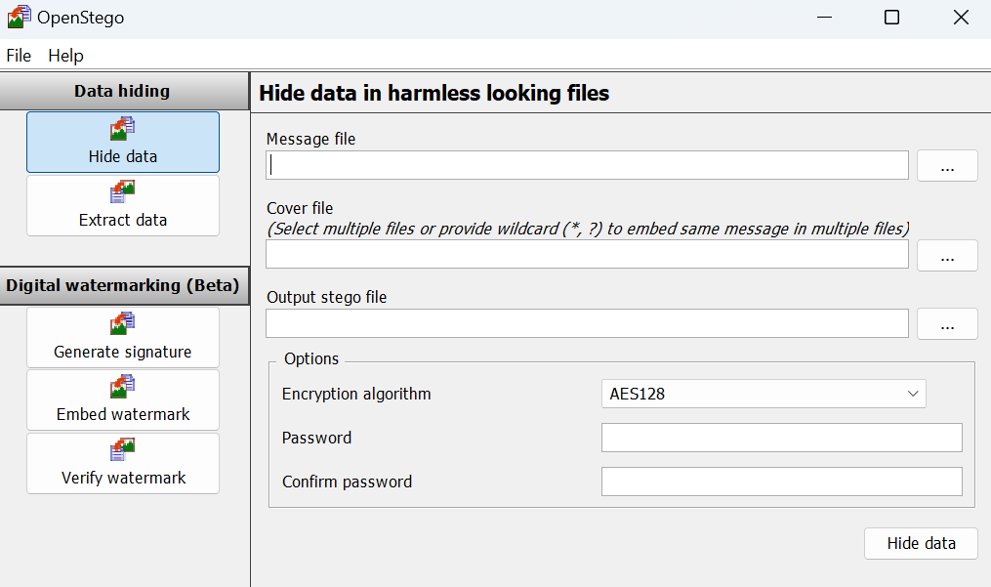

Choose massage txt file you want to hide in image file
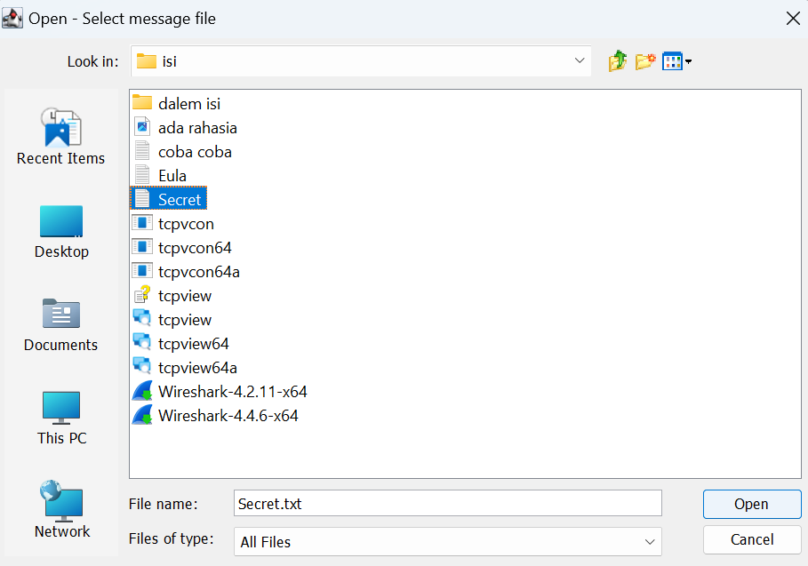

HIDE FILE USING OPENSTEGO

Choose Image file cover
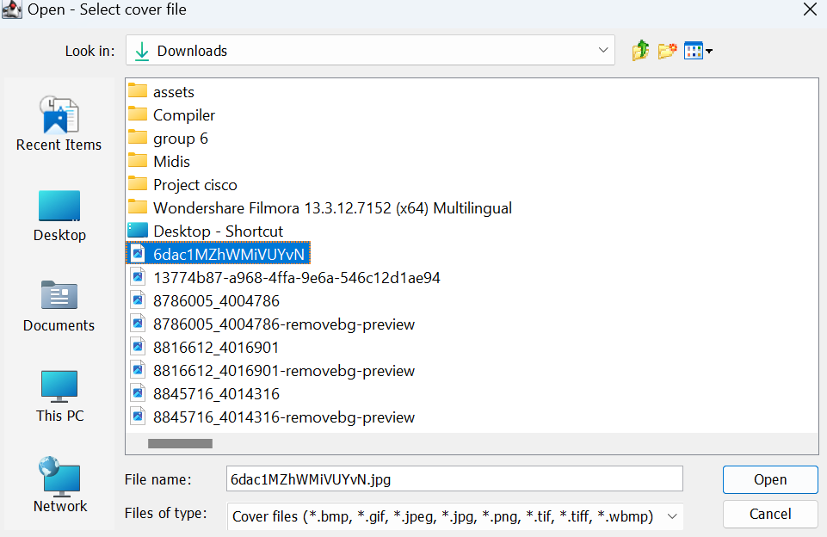

Choose where the output file will be saved and name the output file.

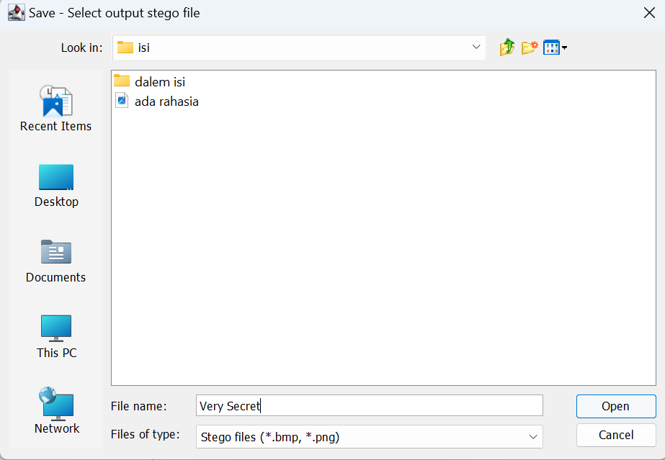

HIDE FILE USING OPENSTEGO

Creat password and choose encrytion algorthm
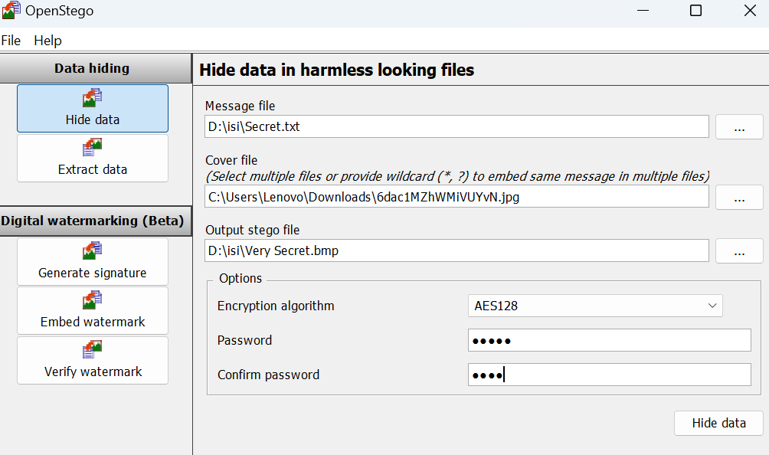

Click hide and the file is successfully hidden.
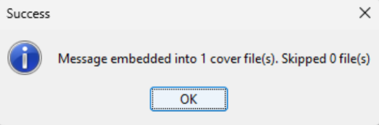

WINRAR INSTALLATION
Download WinRAR at https://www.win-rar.com/download.html?&L=0
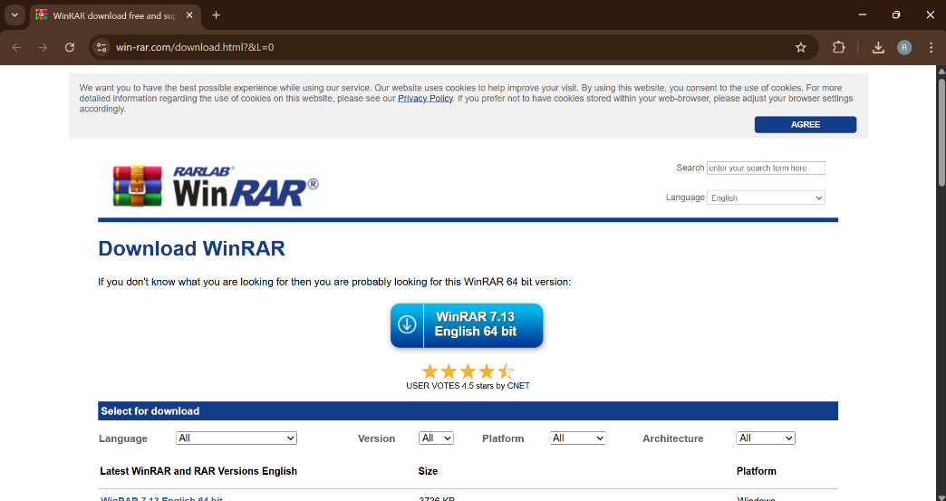

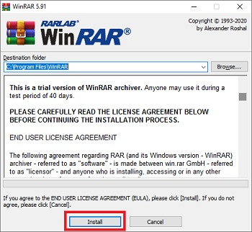
Choose the direktory for WinRAR installation and click install

WINRAR INSTALLATION
Click OK after selecting parameters you need
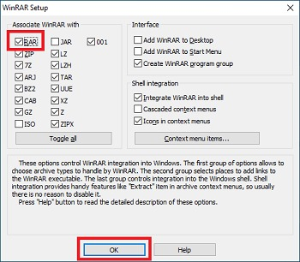

Click done and you have succesfully installed WinRAR
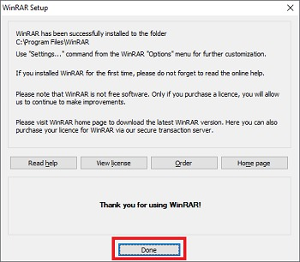

CREATING A PASSWORD PROTECTED FILE ARCHIVE
Right click on the OpenStego output file, then click WinRAR and select “add to srchive”
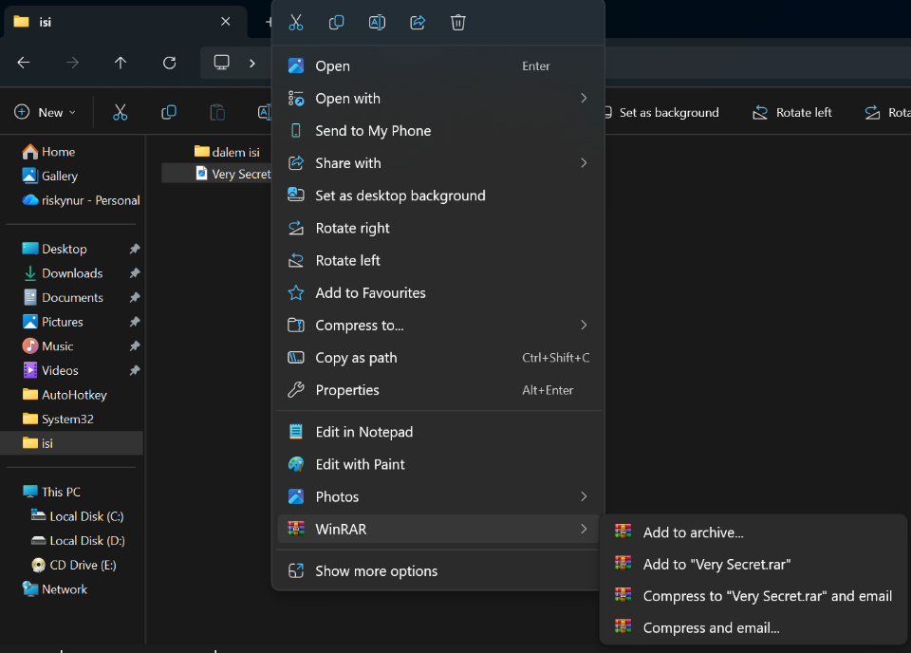

Click set the password after selecting parameters you need
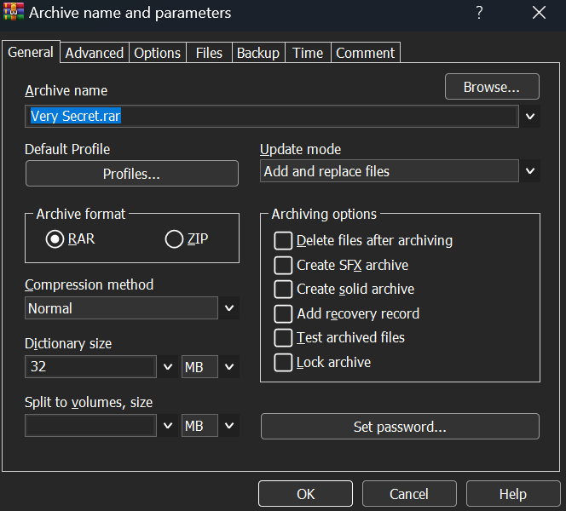

CREATING A PASSWORD PROTECTED FILE ARCHIVE

Click OK after enter the password you want
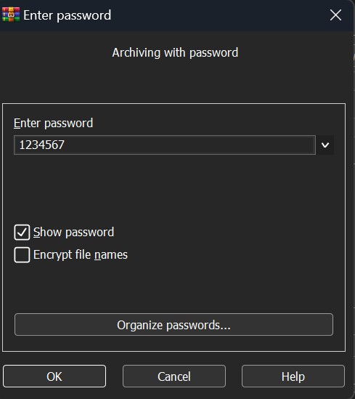

You have succesfully creating a password protected file archive
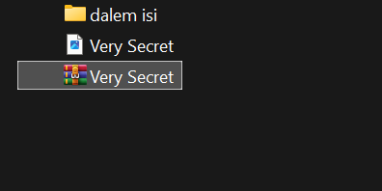

EXTRACTION FLOW
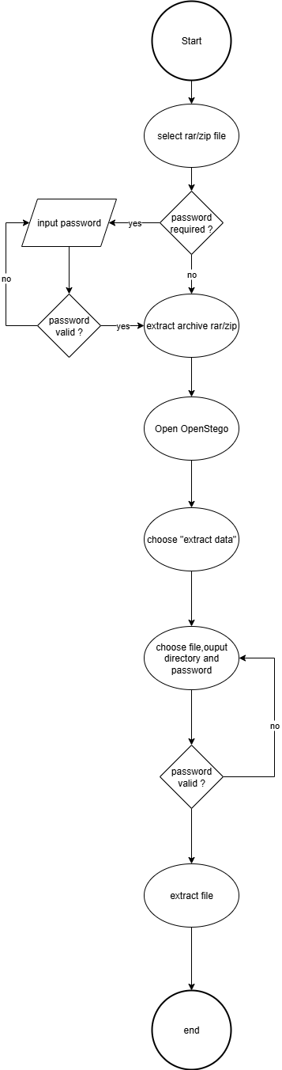

EXCTRACTION
Choose password protected archive file with OpenStego output and select extract file/here
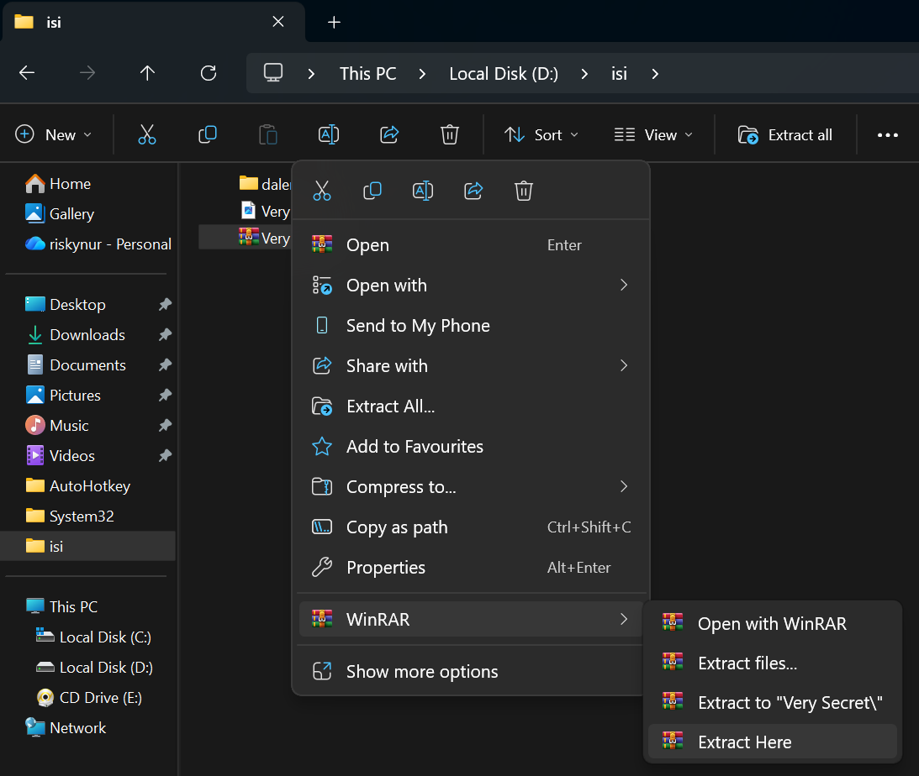

Click OK after enter the password
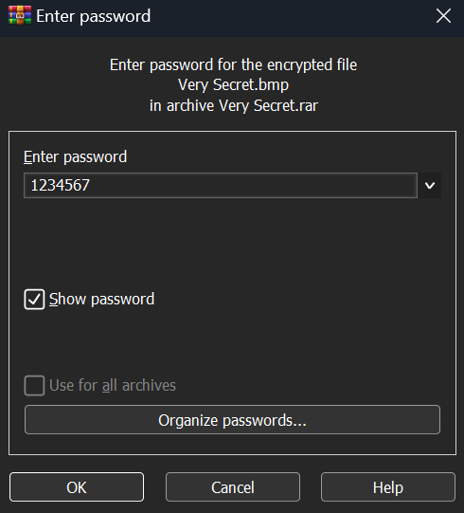

EXCTRACTION
Open OpenStego Software and select exctract data
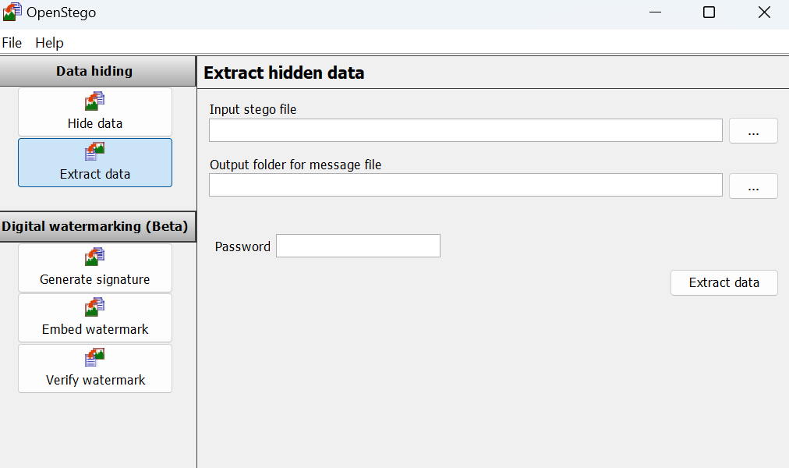

Choose the image that has secret text
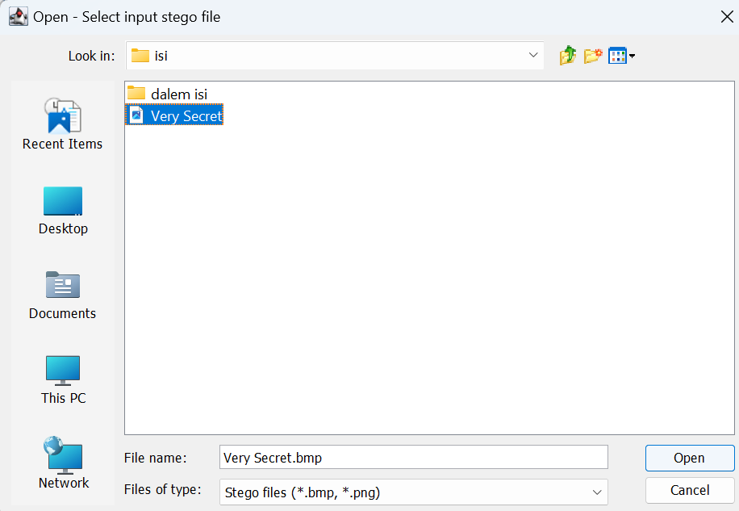

EXCTRACTION
Choose the output directory
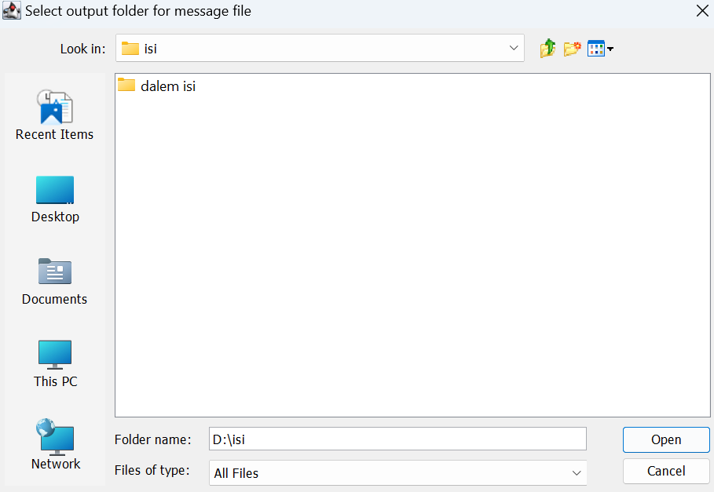

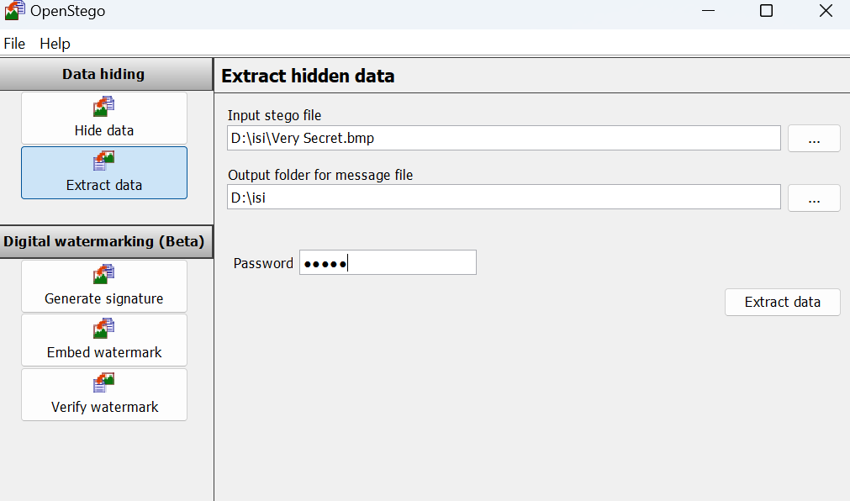
Click Exctract data after enter the password

EXCTRACTION
Extraction succes and you can open the secret text
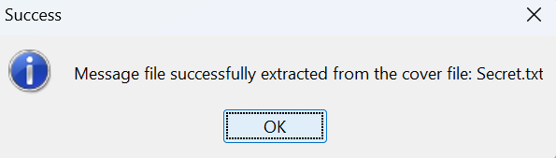

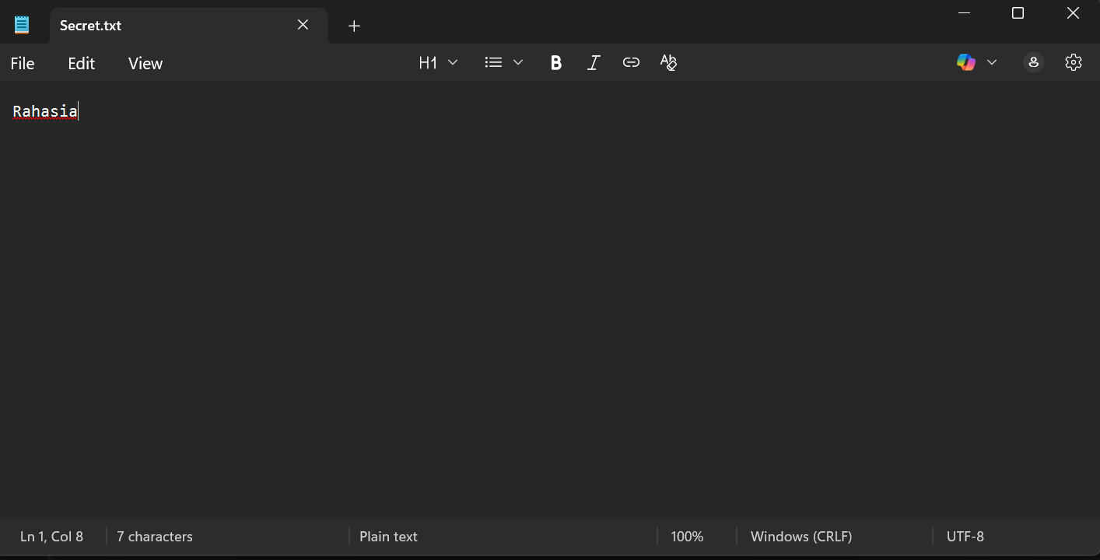
Secret text

REQUIREMENTS

Hardware : Laptop

Operating system : Windows 11

Software : OpenStego
WinRAR
Link :
Project File detail
File Name | Remark
Project 2 Group 7 3CS1 | Microsoft word that contains report
PPT Project 2 Group 7 3CS1 | Presentation File

